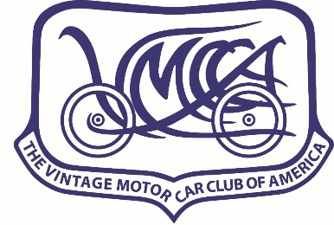

The following Owner/Driver commitment/release statement, in its entirety, must be included in all VMCCA National, Region and Chapter tour or meet registration forms as per VMCCA Board of Governors Directive.

**OWNER/DRIVER COMMITMENT/RELEASE STATEMENT**

Owner ______________________________ Driver (if different) ____________________________

Address ____________________________________________________________________________

Vehicle: Year ___________ Make _______________________________________________________

State Registered in (domicile state) _______________ License number ________________________

I hereby agree to enter the vehicle described in the Vintage Motor Car Club of America event ____(name of event)____. In consideration of the right to enter this event and for other valuable considerations, I (we) do hereby agree to indemnify, protect, defend and hold harmless The Vintage Motor Car Club of America and its Chapters and/or Regions, Officers and Representatives from and against any and all claims, costs, liabilities and attorneys' fees arising from damage or injury, actual or claimed, of any kind or nature, to property or persons, resulting from my (our) participation in the ____(name of event)____.

The owner/driver has proof of bodily injury and property damage liability insurance on the entered vehicle in the amount of at least $100,000 per person, $300,000 per accident bodily injury liability and $100,000 property damage liability, or $300,000 combined single limit liability insurance. Insurance company name ___________________________________, policy no. ___________________, policy term (dates) _________ to ____________.

The owner/driver certifies that the described vehicle entered in this event has duly passed the requirements of the motor vehicle authorities, or other governing bodies of the state in which the vehicle is registered, and the vehicle shall be legally registered and/or licensed. The Vintage Motor Car Club of America and its representatives will not, and cannot, be held responsible for the "safety certification" of any participating vehicle.

Signed ________________________________ ______________________________________

Owner Driver (if different)

Date __________________________ ______________________________________

Revised 2/4/2021